

**Homework # 3**

**01286233 Web Programming**

**Software Engineering Program**

**Faculty of Engineering, KMITL**

By

65011304 Inthat Sappipat

1.

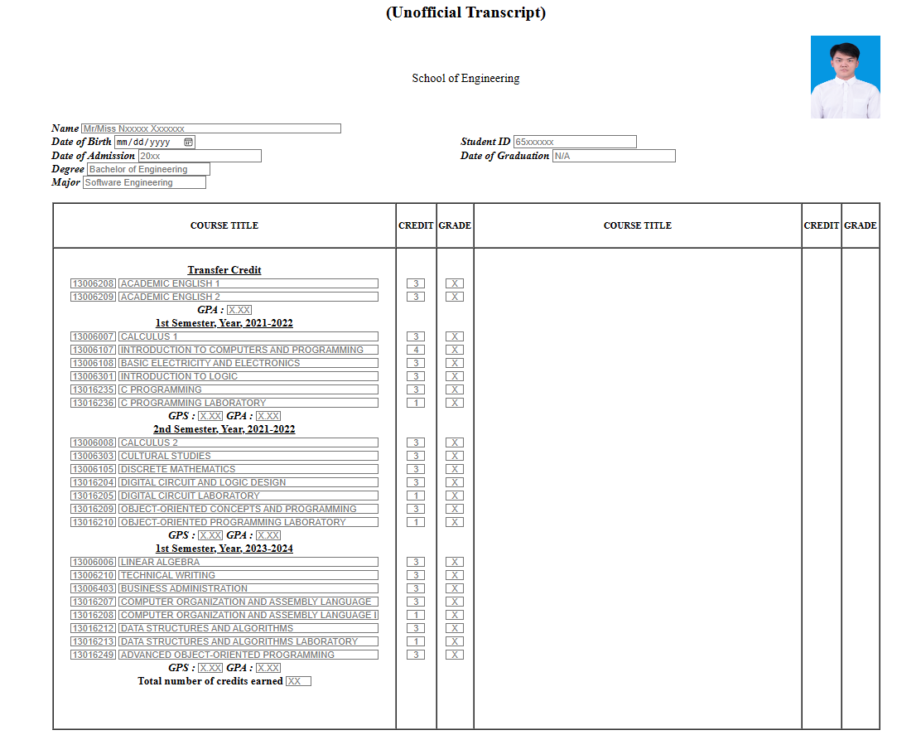Result: